**Tutorial No. 2**

**Problem statement:**

**Design Assumptions:**

**Design Diagrams:**

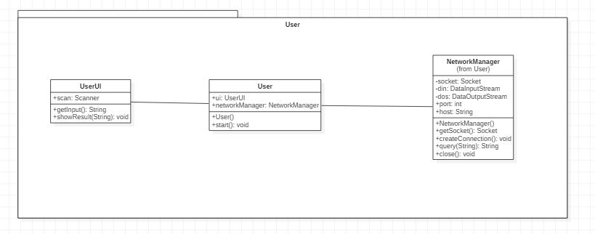

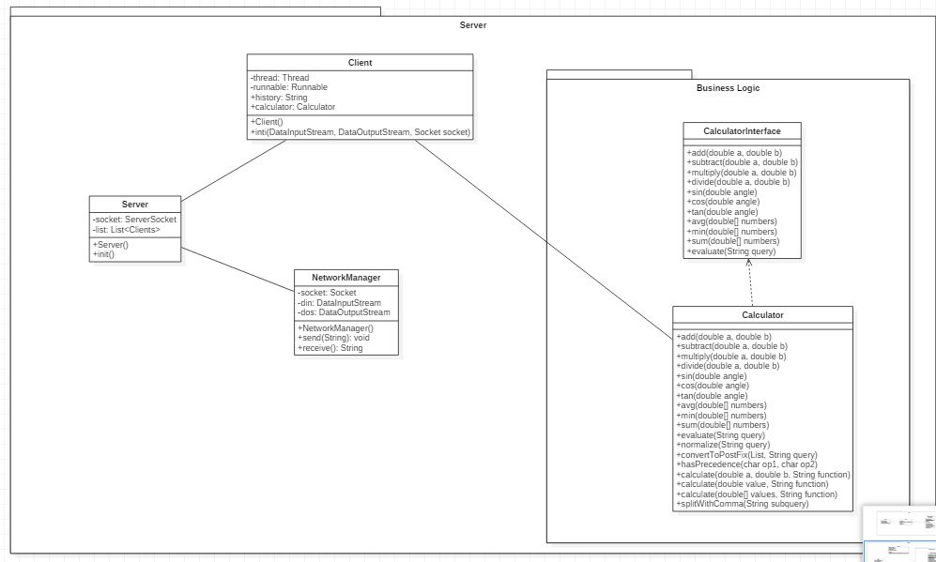

**Code:**

**Calculator.java**

************************************************************************

package com.mangnaik.yogesh.tutorial2.server;

import java.util.ArrayList;

import java.util.List;

import java.util.Stack;

public class Calculator implements CalculatorInterface {

@Override

public double add(double a, double b) {

return a+b;

}

@Override

public double subtract(double a, double b) {

return a-b;

}

@Override

public double multiply(double a, double b) {

return a*b;

}

@Override

public double divide(double a, double b) {

return a/b;

}

@Override

public double evaluate(String query) {

query = query.replaceAll("pi", "3.1415926535");

List<String> list = new ArrayList<>();

//query = normalize(query);

convertToPostFix(list, query);

return evaluate(list);

}

private double evaluate(List<String> list){

Stack<String> stack = new Stack<>();

for(int i=0; i<list.size(); i++){

if(list.get(i).equals("+")||list.get(i).equals("-")||list.get(i).equals("*")||list.get(i).equals("/")){

double a = Double.parseDouble(stack.pop());

double b = Double.parseDouble(stack.pop());

stack.push(""+calculate(a,b,list.get(i).charAt(0)+""));

}

else{

stack.push(list.get(i));

}

}

return Double.valueOf(stack.pop());

}

private void convertToPostFix(List<String> list, String query) {

Stack<Character> operators = new Stack<>();

char[] tokens = query.toCharArray();

for(int i=0; i<tokens.length; i++){

if (tokens[i]>='0'&&tokens[i]<='9'){

StringBuilder stringBuilder = new StringBuilder();

while (i < tokens.length && (tokens[i]=='.' || (tokens[i] >= '0' && tokens[i] <= '9'))){

stringBuilder.append(tokens[i++]);

}

i--;

list.add(stringBuilder.toString());

}

else if(tokens[i] == '(')

operators.push('(');

else if (tokens[i] == ')'){

while (operators.peek() != '(')

list.add(operators.pop()+"");

operators.pop();

}

else if (tokens[i] == '+' || tokens[i] == '-' || tokens[i] == '*' || tokens[i] == '/'){

while (!operators.empty() && hasPrecedence(tokens[i], operators.peek())){

list.add(operators.pop()+"");

}

operators.push(tokens[i]);

}

}

while (!operators.empty())

list.add(operators.pop()+"");

}

private boolean hasPrecedence(char op1, char op2) {

if (op2 == '(' || op2 == ')')

return false;

if ((op1 == '*' || op1 == '/') && (op2 == '+' || op2 == '-'))

return false;

else

return true;

}

//calling arithmetic functions

private double calculate(double a, double b, String function){

switch (function){

case "+":

return add(a,b);

case "-":

return subtract(b,a);

case "*":

return multiply(a,b);

case "/":

return divide(b,a);

}

return 0;

}

}

**CalculatorInterface.java**

************************************************************************

package com.mangnaik.yogesh.tutorial2.server;

public interface CalculatorInterface {

//basic

public double add(double a, double b);

public double subtract(double a, double b);

public double multiply(double a, double b);

public double divide(double a, double b);

public double evaluate(String query);

}

**Client.java**

************************************************************************

package com.mangnaik.yogesh.tutorial2.server;

import java.io.DataInputStream;

import java.io.DataOutputStream;

import java.io.IOException;

import java.net.Socket;

public class Client {

private Thread thread;

private Runnable runnable;

private String history;

private Calculator calculator;

public Client(DataInputStream dis, DataOutputStream dos, Socket socket) {

init(dis, dos, socket);

}

public void init(DataInputStream dis, DataOutputStream dos, Socket socket){

NetworkManager networkManager = new NetworkManager(dis, dos, socket);

calculator = new Calculator();

history = "";

runnable = () -> {

while (true) {

String query = null;

try {

query = networkManager.receive();

history += query + "\n";

System.out.println("Request from : " + networkManager.getPort());

} catch (IOException e) {

e.printStackTrace();

break;

}

System.out.println(query);

if(!query.equals("exit")){

String answer = calculator.evaluate(query) + "";

history += answer + "\n";

try {

networkManager.send(answer);

} catch (IOException e) {

e.printStackTrace();

}

}

else{

try {

networkManager.send(history);

break;

} catch (IOException e) {

e.printStackTrace();

break;

}

}

}

};

thread = new Thread(runnable);

thread.start();

}

}

**NetworkManager.java**

************************************************************************

package com.mangnaik.yogesh.tutorial2.server;

import java.io.DataInputStream;

import java.io.DataOutputStream;

import java.io.IOException;

import java.net.Socket;

public class NetworkManager {

final private DataInputStream dis;

final private DataOutputStream dos;

final private Socket socket;

public NetworkManager(DataInputStream dis, DataOutputStream dos, Socket socket){

this.dis = dis;

this.dos = dos;

this.socket = socket;

}

public int getPort(){

return socket.getPort();

}

public String receive() throws IOException{

String received;

received = dis.readUTF();

if (received.equals("Hello")) {

System.out.println("Working");

return "Hello";

}

else{

System.out.println(received);

return received;

}

}

public void send(String answer) throws IOException {

dos.writeUTF(answer);

}

}

**Server.java**

************************************************************************

package com.mangnaik.yogesh.tutorial2.server;

import java.io.DataInputStream;

import java.io.DataOutputStream;

import java.io.IOException;

import java.net.ServerSocket;

import java.net.Socket;

import java.util.ArrayList;

import java.util.List;

public class Server {

ServerSocket socket;

List<Client> clients = new ArrayList<>();

Calculator calculator;

public Server(){

calculator = new Calculator();

init();

}

public void init(){

try {

socket = new ServerSocket(8192);

} catch (IOException e) {

e.printStackTrace();

System.out.println("Failed to create Server!!");

}

while(true){

Socket s;

try{

s = socket.accept();

System.out.println("A new client has connected");

DataInputStream dis = new DataInputStream(s.getInputStream());

DataOutputStream dos = new DataOutputStream(s.getOutputStream());

clients.add(new Client(dis, dos, s));

} catch (IOException e) {

e.printStackTrace();

}

}

}

public static void main(String[] args){

new Server();

}

}

**NetworkManager.java**

************************************************************************

package com.mangnaik.yogesh.tutorial2.user;

import java.io.DataInputStream;

import java.io.DataOutputStream;

import java.io.IOException;

import java.net.Socket;

public class NetworkManager {

Socket socket = null;

DataInputStream din = null;

DataOutputStream dout = null;

int port;

String host;

public NetworkManager(String host, int port){

this.port = port;

this.host = host;

}

private Socket getSocket() throws IOException {

return new Socket(host, port);

}

public void createConnection(){

try {

socket = getSocket();

} catch (IOException e) {

e.printStackTrace();

System.out.println ("Failed to Create Socket");

return;

}

try {

din = new DataInputStream(socket.getInputStream());

dout = new DataOutputStream(socket.getOutputStream());

} catch (IOException e) {

e.printStackTrace();

System.out.println("Failed to connect to the server");

return;

}

}

public String query(String query) throws IOException {

dout.writeUTF(query);

return din.readUTF();

}

public void close() {

try {

socket.close();

} catch (IOException e) {

e.printStackTrace();

}

}

}

**User.java**

************************************************************************

package com.mangnaik.yogesh.tutorial2.user;

import java.io.IOException;

import java.util.Scanner;

public class User {

Scanner scan = new Scanner(System.in);

UserUI ui;

public static void main(String args[]) {

new User();

}

public User() {

ui = new UserUI();

start();

}

public void start(){

NetworkManager networkManager = new NetworkManager("localhost", 8192);

networkManager.createConnection();

String query = "";

while(!query.equals("exit")){

query = ui.getInput();

if(!query.equals("")){

String ans;

try {

ans = networkManager.query(query);

} catch (IOException e) {

ui.showResult("Connection Reset");

networkManager.close();

return;

}

ui.showResult(ans);

}

}

}

}

**UserUI.java**

************************************************************************

package com.mangnaik.yogesh.tutorial2.user;

import java.util.Scanner;

public class UserUI {

Scanner scan = new Scanner(System.in);

public String getInput(){

String query = scan.nextLine();

return query;

}

public void showResult(String answer){

System.out.println(answer);

}

}